**Rip Lyster**

**15-112**

**David Kosbie**

**11/22/16**

**Competitive Analysis of 3d Printer Slicers**

In consumer 3d printing technologies there are 2 main pieces of software. The first piece is the 3d modeler which the consumer uses to create their 3d object. The second is the slicer which is used to slice the 3d model created in the modeler and create a gcode file that is used by the 3d printer to create the object. My project runs along the line between these two softwares.

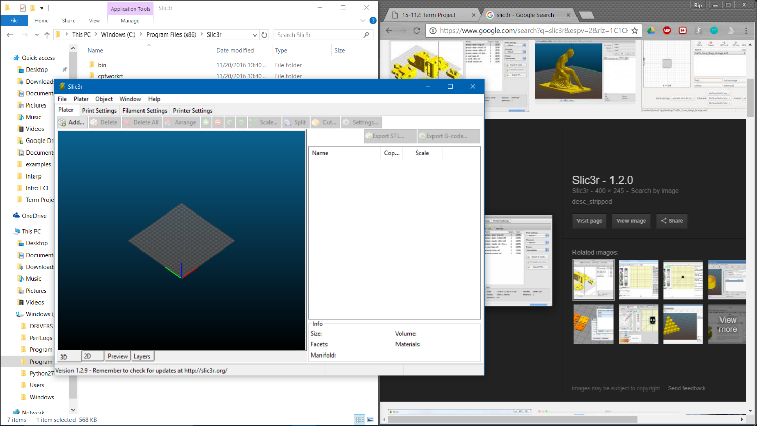There are many slicer programs to choose from as a consumer. The most popular one used among hobbyists would be Slic3r. Slic3r (on the right) is a very complex software that can take any STL file and turn it into gcode using multiple fill setting and multiple layer settings. I really like this about Slic3r and plan to implement fill and layer settings in my project. I don’t really like all the different tabs in slicer however and want to put all the settings necessary to create the actual gcode in the same window as the drawing window.

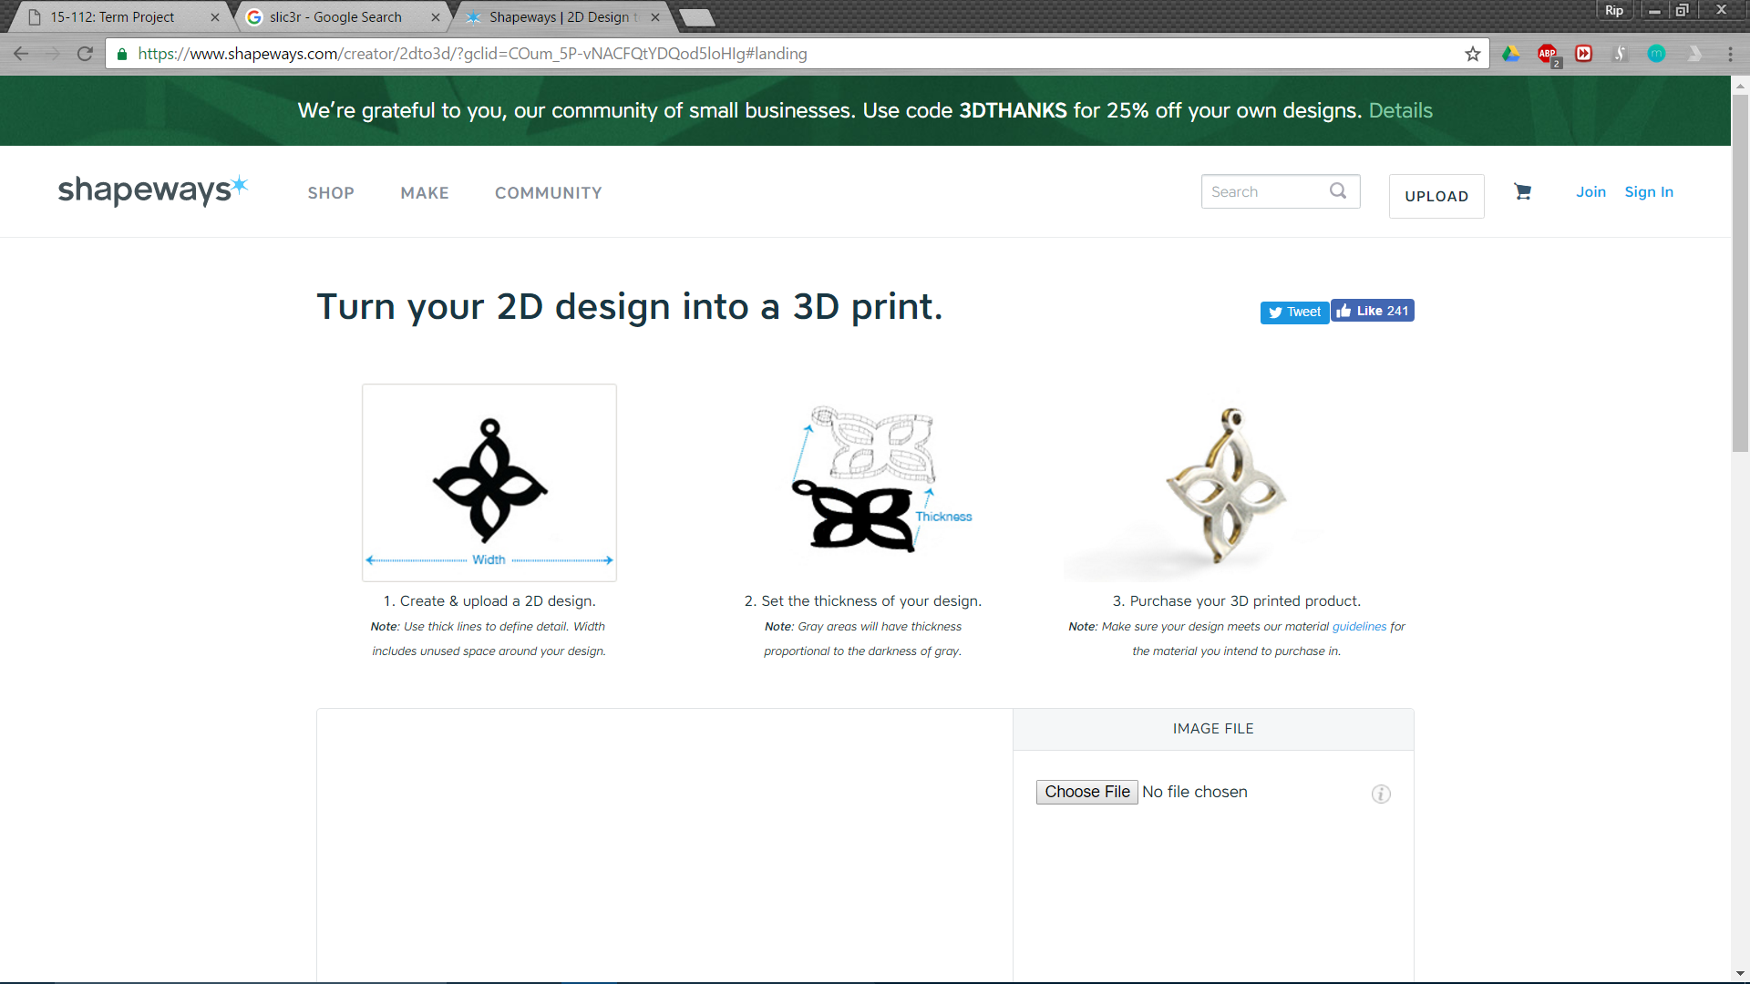A program that is very similar to my program is Shapeways’ 2d to 3d App. Shapeways is a 3d printing service for people that do not have immediate access to a 3d printer. Consumers can go to the 2d to 3d app and draw and image and then get that printed in 3 dimensions. This app was the inspiration for this project. I really enjoyed the idea of creating something in 2d and having it produced in 3d. It is also a great introduction to 3d printing for many curious consumers. Shapeways only allows consumers to purchase their creation off of their website and doesn’t allow downloads of the files. This limits the potential of the app as a great introductory tool to 3d printing. My program allows for the user to directly take their drawing and output it into a gcode file. This enhances the user experience and allows for easy use of the 3d printer programs.